2026
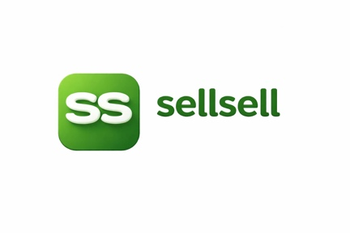
sellsell marketplace updates:

Shaz EJ
This is a very valuable QA result. Based on the report, here is the actual status of SellSell today:

Executive Summary

Platform Status
Area | Status
Login | ✅ Working
Registration | ✅ Working
AI Search | ✅ Working
Arabic Search | ✅ Working
English Search | ✅ Working
Demand Capture Agent | ✅ Working
Seller Draft Generation | ✅ Working
Mobile Responsive UI | ✅ Working
Product Cards | ✅ Working
Search Relevance | ✅ Working
Admin Dashboard | ❌ Critical Bug
Session Persistence | ❌ Critical Bug

Critical Issues Before Demo

1. Silent Logout Bug (P0)

Problem
When a user:
- Logs in
- Goes to Explore
- Refreshes page
The system calls:
/api/auth/refresh
and receives:
401 Unauthorized
Then:
User gets silently logged out
Redirected to landing page

Why Fahad Will Notice
Fahad usually:
- logs in
- clicks around
- refreshes pages
This bug will appear immediately during a demo.

Priority
🔥 Fix Today

2. Admin Dashboard Crash (P0)

Problem
Opening:
https://sell-sell.com/admin
causes:
React Error #419
Error:
Cannot destructure property
'getFieldState'

Impact
Admin dashboard becomes unusable.

Priority
🔥 Fix Today

What Passed

AI Search
Examples tested:
Mazda SUV
Toyota
Nike Air Jordan
شاليه في الخيران
Result:
✅ Relevant cards returned
✅ Arabic understanding works
✅ English understanding works

Demand Capture Agent
Examples:
Toyota Prado 2026
iPhone 18 Pro Max
Result:
Would you like to be notified when available?
User:
Yes
Result:

✅ Alert created

User:
No
Result:
✅ Alert cancelled
This means the entire Demand Capture Agent pipeline is functioning.

Seller Flow
Seller writes:
I want to sell Mazda CX9 2023
Result:
✅ Draft generated
✅ Preview shown

Mobile
Result:
✅ Responsive
✅ Sidebar collapses
✅ Chat usable
✅ Layout looks professional

Actual Completion Percentage
After QA:
Component | Completion
AI Marketplace Core | 100%
Search Engine | 95%
Demand Capture Agent | 100%
Seller Draft Agent | 95%
Moderation Pipeline | 90%
Indexing Pipeline | 95%
Notifications | 90%
Mobile UI | 90%
Admin Dashboard | 70%
Production Hardening | 80%
Overall:

MVP Completion: 98%

Production Readiness: 92%

Recommended Next Actions

Today
- Fix /api/auth/refresh 401 issue
- Fix Admin Dashboard crash
- Re-run QA

Tomorrow
- Test notifications end-to-end
- Test saved alerts end-to-end
- Test seller listing publication end-to-end
- Test moderation workflow

This Week
- Admin monitoring dashboard
- Notification center
- Production monitoring
- Error tracking
- Backup automation

